**DESIGN BRIEF!**

____________________________________________

CRAFTING MY PORTFOLIO WITH HTML & CSS

By Mary-Elie Yao

Grade: 10/MYP year 5

Criterion A: Inquiring & Analyzing

____________________________________________________________________________

> I’ve done some research on examples of personal portfolio websites using HTML and CSS, and I found some pretty nice templates that inspired my portfolio. You can likely find these templates on websites like Gifthub, Codepen portfolio examples, W3Layouts, tooplate, and Free CSS. Some of the principles I noticed in all the templates are that they all have a clean and minimal design focusing on simplicity, creating a sense of balance and professionalism, and using a simple but not complicated color scheme that coordinates with each color used. Another important principle is that the Responsiveness of the websites should work on any device. The showcase of your work should be well-organized and not unorganized. Navigation should be smooth and have the key aspects (home, about me/Portfolio, and Contacts). Your Performance Optimization Counts as Well Minimize file sizes (e.g., compress images and use efficient CSS coding) to ensure fast loading times, and also use external css to keep your work in order. Your branding should be noticeable using professional photos, logos, and a well-structured bio. Typography and visual hierarchy should be noticeable as well, such as titles and subtitles. Interactive Features using hover effects and animation just adds a little uniqueness to your portfolio. The last two principles that I noticed are Accessibility, making sure your website is accessible to everyone, and a CTA (call to action), including it for professional purposes, guiding the audiences to take specific actions such as Hiring, Viewing projects, and more.

I will explain the foundation of My Portfolio, which is HTML(hypertext markup language) and CSS(cascading stylesheet). I will first explain both of their uses separately and then how they work together. HTML is the backbone of any webpage. It's a markup language used to create the structure and content of a website. Think of HTML as the "bones" of a website.

**Purpose**: It defines elements such as headings, paragraphs, images, links, and buttons.

**Core Concept**: HTML uses "tags" to structure content. For example:(<h1></p><head>)

Each tag has a specific role, and together, they form a structured document that browsers can render. However, on its own, HTML lacks styling—it’s mostly plain and basic.

CSS is what brings visual appeal to a webpage. It's used to control the appearance and layout of HTML elements. Think of CSS as the "skin" and "clothes" of a website.

**Purpose**: It styles HTML elements by defining properties like colors, fonts, spacing, and positioning.

**Core Concept**: CSS uses "selectors" to target HTML elements and apply styles. For example:( h1{}, body{}, menu-icon{})

CSS can be written in three ways:

1. Inline (inside HTML elements).
2. Internal (within a <style> tag in the HTML file).
3. External (in a separate .css file, linked to the HTML).

Now that we know how both HTML and CSS work separately, let us see what they do when working together. Two things we need to keep in mind from the previous explanation are that HTML provides structure and CSS provides visual appeal, so they work together by HTML providing the structure, while CSS enhances the presentation. They complement each other to create fully functional and visually appealing websites. HTML defines the content, text, and images on the page. CSS defines how it looks by using fonts, colors, and layouts I would say my audience is my teacher, classmates, peers or future business, and school that will look through my portfolio so I would say I have a wide variety of audience

_____________________________________________________________

Criterion B: Developing Ideas

___________________________________

> Here are some sketches of how my Portfolio website will resemble

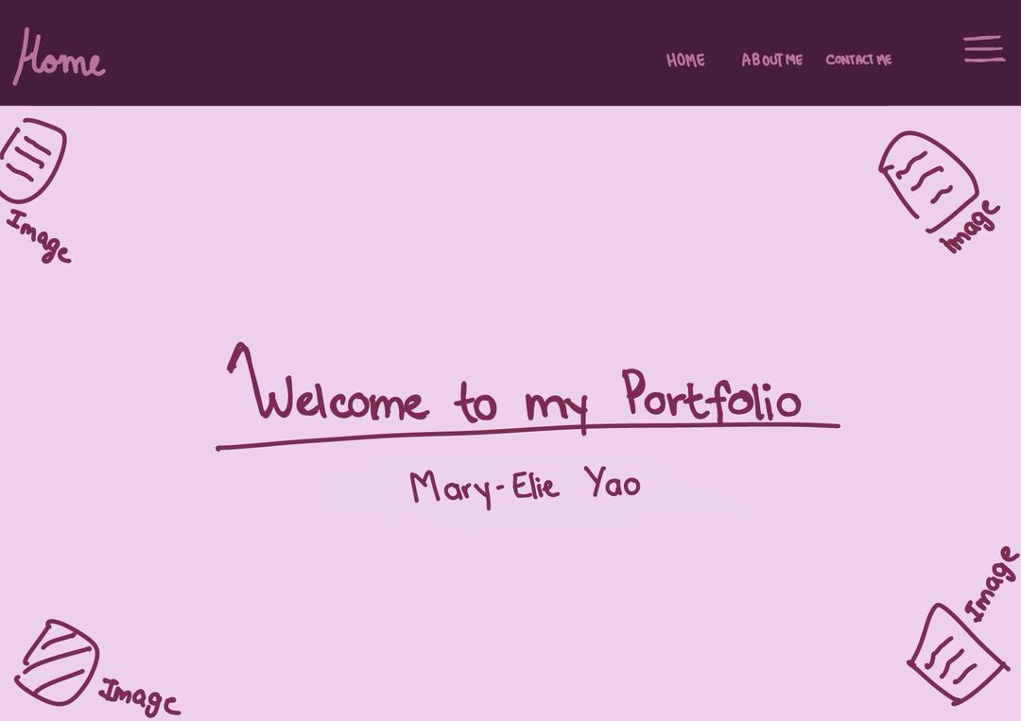 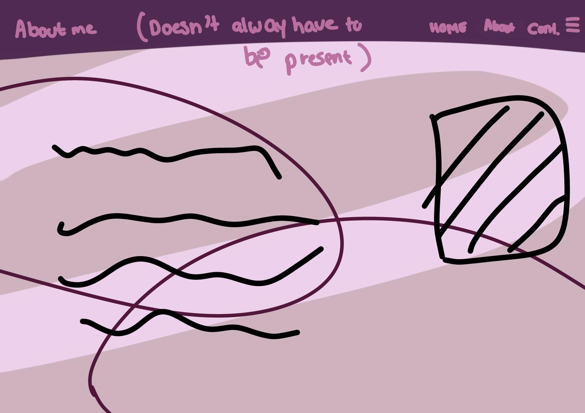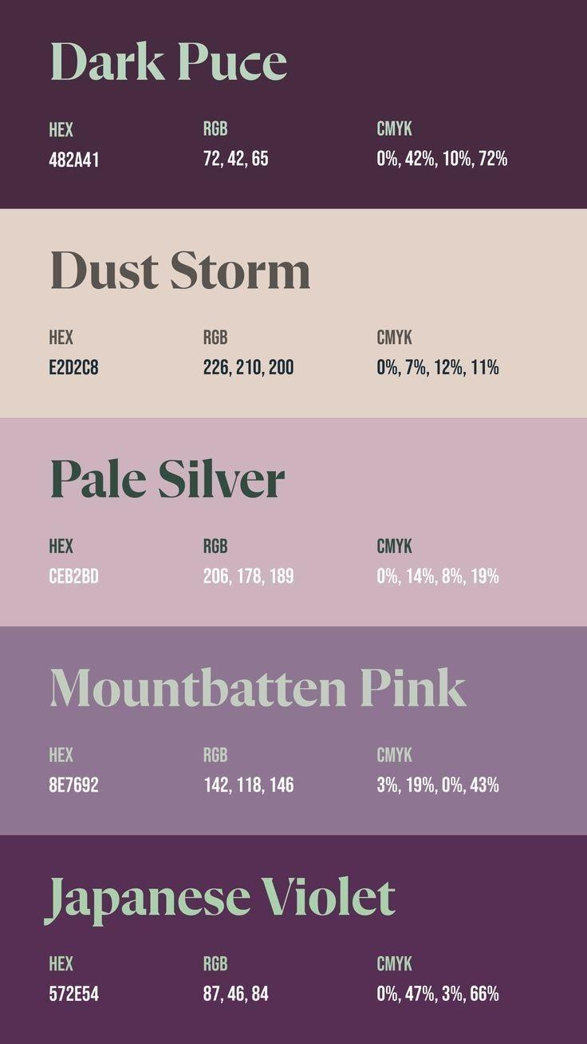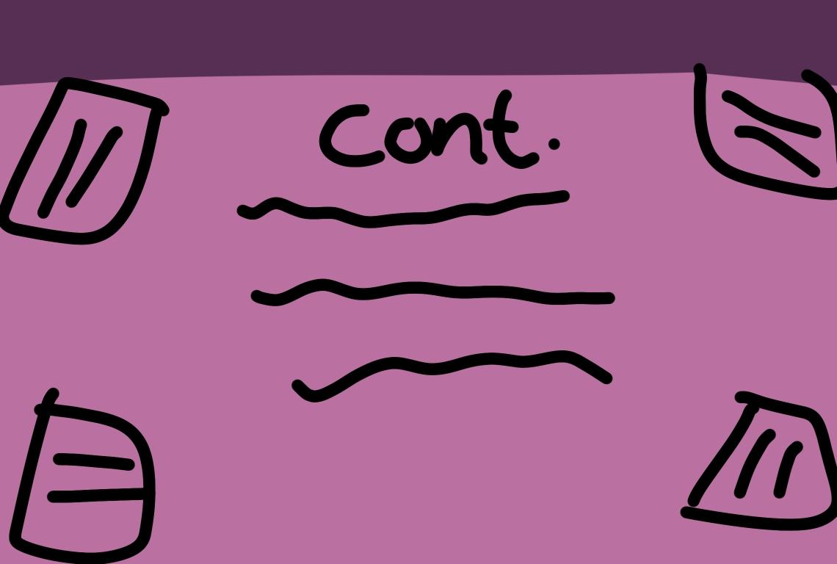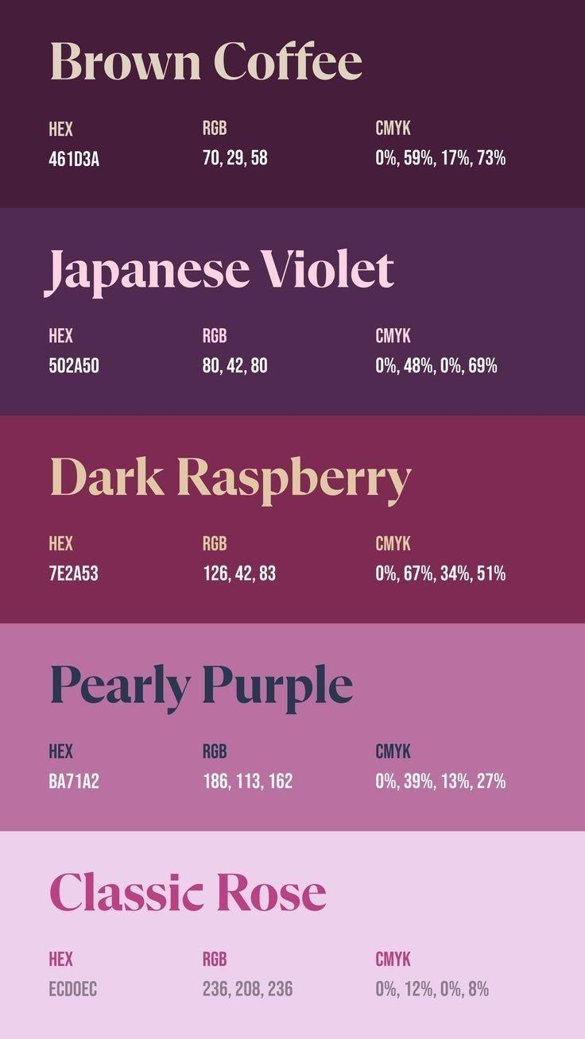

Here are the sketches and the color schemes I used for my website I'm going for a purple mix which gives a professional but classy and elegant vibe and purple is a nice color as well so the 1st picture shows the first thing you will see when entering my website its contains 4 images and the navbar. The second picture shows how my about me/portfolio page will look it will contain one image and some writing about myself. The picture in between the color scheme pictures is how my contact page will look like also contains images for decoration.

Criterion C: Creating Solutions

___________________________________

My coding process wasn't easy because it was my first time using HTML and CSS together but with the help of my previous codes, friends, research, and my teachers' help. With their help, I came out with a nice Personal Portfolio website. I’ve had problems mostly with css sometimes I would have problems linking my CSS to HTML and using it generally but I found solutions and I did some changing some things to also enhance my website. Some main issues were backgrounds wouldn't work so I had to retype codes many times which was frustrating. I had to go through every single code again and again to see the mistake I made until I found it and had to change many things. It got to the point where I had to start comparing my codes again and again some of the results of my codes weren't giving me what I wanted so I had to change them. It was just a long process very tiring but when I started to master my mistakes I redid and it was even better the part I disliked the most was when I had to restart everything multiple times over and over again. I like my website even though it doesn’t match my sketches so much but it acts like a guide and that's all that matters because I also made last-minute changes to upgrade it to my liking but yeah coding isn't easy and requires patience and attentiveness.

________________________________________________________________

Criterion D: Evaluating

___________________________________________

My Website does meet some of my success criteria like the color of the scheme and my pictures and information, and I like the way it looks but I feel like if I had more experience in Coding with HTML and Css I could have done something more unique and original with experience. So I hope if I were to do this in the future I would know more about how to manage CSS and HTML.

I’ve gotten a few comments from my peers about my website which helped me know my lackings and where I can improve and where I can did good.

Linda said my website was nice and gave me some constructive criticism by saying I could add more dimensions and animation/pictur.es that could make it look more professional and unique to fit my style.

My mom said it was very nice but more experience would help a lot.

Some of my other classmates said it was beautiful but missed something that could make it pop.

Khloe said that is beautiful but my about me page could have been made a bit more neat and added more pictures and that she loves my contact page.

So my overall challenge I would say was CSS I would like to master it first even more so I can make nice more dimensional and decorative websites.

_____________________________THANK YOU____________________________